MT Sensor Project Report Ⅰ (February 2020)

Yuan Xiaosong, Yu Angquan

**Background**

The solar wind can cause an electromagnetic field around the earth. The details of that electromagnetic field need to be measured in different places around earth to gain further knowledge about the phenomenon. However, the data measured by traditional method can only be stored into measuring apparatus and can not update into the computer in base station, which is usually far away from the experiment location. Besides, the power consumption of the traditional way is high, and the instrument must be recharged in a few days. To solve the problems, we designed a microcomputer for the storage of data, and it can transmit the data measured to base station synchronously in a relatively low power-consumption.

**Introduction**

Our design a is used to collect the data gained by fluxgate magnetometers in experimental location and transmit the data back to the computer in base station. The two key functions of our design are: 1. Lower the energy consumption of our design and make it can work as lasting as possible 2. Produce stable signal with 4G ability board. To achieve the first function, we choose a rechargeable battery, which can provide power supply to the whole system and recharged by a solar board. Therefore, our design can work wherever the solar energy is available. To achieve the second function, we use a mini computer to get the data from fluxgate magnetometers, process it and control a GPRS module to send data back to base station synchronously. Two kinds of design will be discussed in this report. Both of them consist of four major units as mentioned above, which are power supply, a mini computer, a GPRS module and probes to detect electromagnetic fields. Reasons for choosing each of unit will be discussed. And recommended websites for shopping each of the unit (except probes) will be listed at the end of discussing each of the unit. Then, our two kinds of design will be analyzed so that we will be able to find the advantages and disadvantages of each of the design. The power supply unit will be remained at the end of discussing two kinds of design because the energy consumption of the whole system will be estimated in this part.

**Mini Computer**

We recommend to use Arduino UNO for this unit. The first reason is that it has a built-in watchdog. We have found guidance of using its watchdog on Arduino’s official website, which will help our later work. The second reason is that Arduino has an effective online community for users to post their problems and wait for others’ help. It will be a good help for our later programming.

**GPRS module**

Among SIM GPRS cards, there are six major types, which are SIM800A, SIM800C, SIM800F, SIM800L, SIM868 and SIM900A. The rest types have little production, like SIM808, which only produced for a year and ended up for poor positioning accuracy. Therefore, there are few comments and information for them. We think they are not trust worthy. Among the listed six types, we searched online for the users’ comments and recommendations as well as online stores for their detail information. We find that SIM900A is the out-of-date version which is about to stop production. SIM800L cannot upload data. SIM800C, SIM800F, SIM868 are similar but each has a unique function that others don’t have. We recommend SIM800C because the unique function on it is BLUETOOTH. Maybe we can also use it to connect with other units in later projects. There are other effective features that SIM800C has. Its size is 17.6*15.7*2.3 mm [1] (the whole module is 62*52.5*?mm) [2], which is the smallest among them. In addition, users online commented that SIM800C has good stability. Its working temperature is -40 ~ 85 ℃ [2], which is able to work in most of the areas in the earth. Overall, we think SIM80C is a good choice. There are two good stores on Taobao celling SIM800C. Price is cheap and customers’ comments are good. The first website sells an entire SIM800C module, including a printed circuit board organizing SIM800C chip, SD card circuit and antenna and so on.

<https://item.taobao.com/item.htm?spm=a1z0d.6639537.1997196601.4.ff367484hhr5Kl&id=540672563189>

The second website sells only the SIM800C chip.

<https://detail.tmall.com/item.htm?spm=a230r.1.14.51.468c4c10yt2JsT&id=525624002439&ns=1&abbucket=16>

**Design Ⅰ**

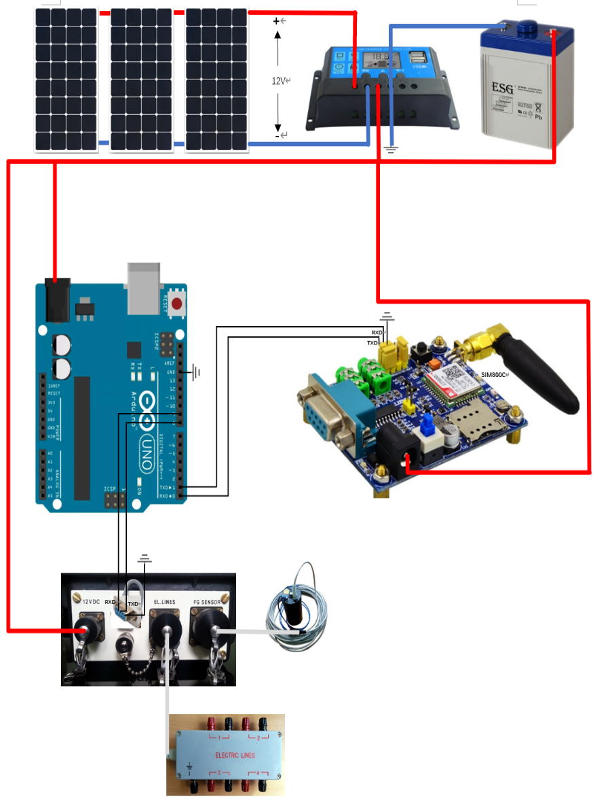

Figure 1

photovoltaic controller

In Design Ⅰ we use the ready-made SIM800C module from the first shopping website listed in the GPRS-module-choosing part. We choose to use 12V storage battery because all the photovoltaic controllers we found had a minimum processing voltage of 12 volts. The voltage range that can be applied to Arduino UNO through the power port (as being connected in Figure 1) is 9 ~ 12V DC. We think it is able to work because the voltage will be lower than 12 volts after connecting components if the open circuit voltage of the battery is 12V. We are not sure about that. But we can add a circuit as being showed in Figure 2 to decrease the input voltage of Arduino to 10V and reduced voltage fluctuation at the same time. However, this could raise a problem. That is, it is difficult to weld such a circuit strong enough to make sure it can work for months and not fall to pieces. The input voltage for the SIM800C module in Figure 1 is 5 ~ 24V DC so 12V is suitable for it. And the input voltage for the probe unit is 12V DC so it also works [4].

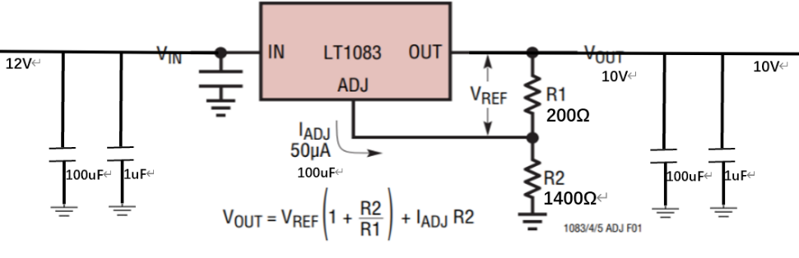

Figure 2

The SIM800C module in Figure 1 has two kinds of ports to handle data transmition, which are TTL and RS232. Both of them can be used in our project. Design Ⅰ uses its TTL port to connect it with Arduino board. The TTL port is the yellow part of the SIM800C module as Figure 1 shows. (Not clearly shown in Figure 1. Maybe the yellow cap should be unpluged.)

The probe unit uses TOM port. It is not shown in the several pictures that Professor Yangbo provided to us. Therefore, a picture of COM port is added to the picture of the probe unit to show the entire circuit, as being shown in Figure 1.

Arduino UNO only has one pair of RXD\TXD pins to handle data transmition. However, two pairs are needed because the Arduino board should be connected with both the probe unit and SIM800C module. Therefore, software is needed to change two normal I\O pins to RXD\TXD pins [3]. Arduino library has provided such software in <SoftwareSerial.h>. The maximum rate for data transmition through Arduino software serial port is about 100bps. We are not sure wether this rate is enough or not. In addition, using software serial port can take up lot of CPU resources. If it is not appropriate, we may need a second Arduino board.

Arduino has a built-in watchdog and software of using it is available to refer to. Arduino can judge wether the probe unit and the SIM800C module is in good condition by processing their response. If any of the unit is not working, the Arduino’s built-in watchdog will reset all three units. Therefore, an extra watchdog is not needed.

The online store that sells the recommended SIM800C module also provides sofeware libraries for their SIM800C, which may help our later programming.

Advantages of Design Ⅰ comparing to Design Ⅱ:

1. The SIM800C module has already solved problems like circuit to starting the SIM800C chip, circuit to reduce voltage fluctuation and circuit to connect with the SD card.

2. Almost no extra circuit is needed, so it is easy to find which element is not working well. In addition, the integrated SIM800C module is strong and not easy to fall to pieces.

3. Software about SIM800C is provided by the online store, which may be good reference.

Disadvantages of Design Ⅰ comparing to Design Ⅱ:

1. SIM800C module is more expensive than a SIM800C chip. The reconmended SIM800C module is 153 yuan but a SIM800C chip is 17.8 yuan.

2. The design philosophy of Design Ⅰ is simply and easy to connect. Therefore, no extra circuit are built to reduce voltage fluctuation. Design Ⅰ may not be good at resisting possible outside interference to voltage.

**Design Ⅱ**

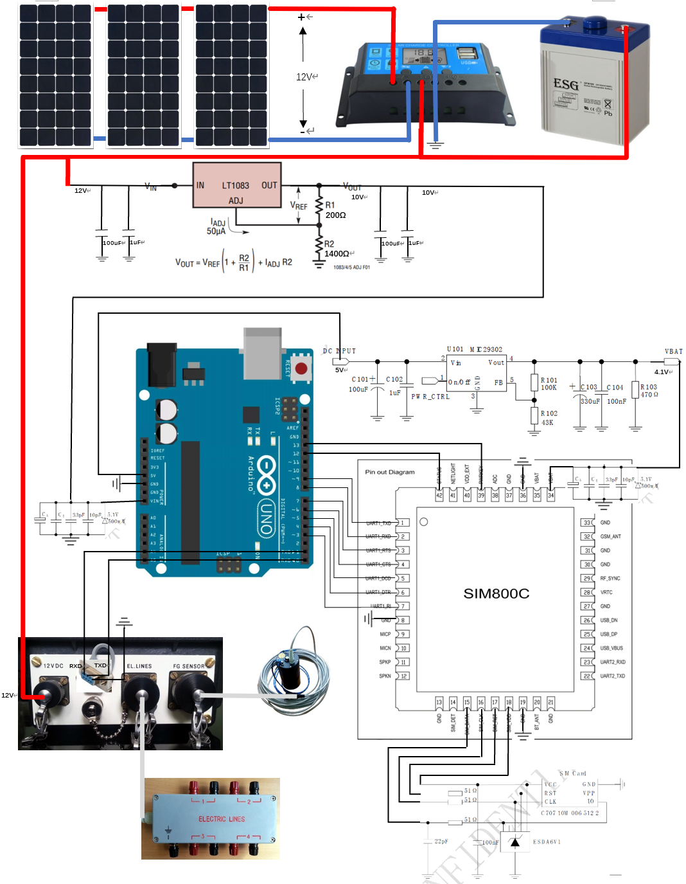

Figure 3

Figure 3.1

Figure 3.2

Figure 3.3

Figure 3.4

Figure 3.5

In Design Ⅱ we use only a SIM800C chip and some extra circuits to reduce voltage fluctuation like Figure 3. It has four units same as Design Ⅰ except for a SIM800C chip instead of SIM800C module. Extra circuits are needed to added to the SIM800C chip.

The circuit shown in Figure 3.1 is used to reduce voltage from 12 volts to 10 volts to make sure that Arduino board works as well as reducing voltage fluctuation. The LT1083 chip is suitable to reduce DC voltage at the magnitude of 2 volts. Its formula is , where is 1.25 volts and is 50 microamps. When R2 is not large, the latter term is able to be ignored. In our design, we choose R2 as 1400 ohms and R1 as 200 ohms, so equals to 1.25 * (1 + 7) = 10 volts. The capacitors are used to reduce voltage fluctuation. It should be built close to battery. The circuit in Figure 3.2 is used to reduce the voltage fluctuation generated in the wire [5]. Therefore, it should be put close enough to Arduino board.

The 5V pin of Arduino board can be used to output 5V DC voltage. Circuit in Figure 3.3 has the same function as Figure 3.1. It is the recommended power supply circuit in SIM800C’s datasheet [5]. It reduces the input voltage from 5 volts to 4.1 volts, which is suitable to SIM800C chip. It should be built close to Arduino’s 5V pin. Circuit in Figure 3.4 has the same function as Figure 3.2, so it should also be close enough to SIM800C chip.

Pin 12 and pin 13 of Arduino board are connected with STATUS and PWRKEY of SIM800C chip respectively, which are used to start SIM800C chip and shut down. Pin 3 to pin 9 of Arduino board are connected with pin 7 to pin 1 of SIM800C chip respectively, which are used to control the SIM800C chip. Pin 8 and pin 9 of Arduino board should be processed with <SoftwareSerial.h> in Arduino library to work as TXD and RXD.

Figure 3.5 is the recommended circuit from SIM800C’s datasheet to connect SIM800C chip with SD card [5].

Advantages of Design Ⅱ comparing to Design Ⅰ:

1. Design Ⅱ is more secure due to its circuit able to reduce voltage fluctuation at both battery output and unit input. Therefore, Design Ⅱ is better at resisting outside interference.

2. Design Ⅱ is cheaper than Design Ⅰ as being analyzed before.

Disadvantages of Design Ⅱ comparing to Design Ⅰ:

1. Design Ⅱ is difficult to build as it has lot of extra circuit.

2. Design Ⅱ has no software support as it uses SIM800C chip rather than SIM800C module built by a company.

3. Some basic components are needed to buy, like a pedestal for SD card.

4. More things are needed to be considered if we use a single SIM800C chip rather than a SIM800C module. For example, program used to start the SIM800C chip and control the SD card.

**Power Supply**

We use a solar board to gain energy from sun. The power of solar board is 50W and its working voltage is 18v. Its size is moderate: 670mm*570mm*25mm [6]. As for the photovoltaic controller, the input voltage is between 12V to 24V, so it fits with the output voltage from solar board. As for the rechargeable battery, the capacity is 20AH. The output voltage is 12V so it fits with Arduino UNO. The output interface of battery can be adjusted to give power supply to Arduino. The power consumption of the whole system is estimated. LEMI-424 (probe unit) has 0.35w power consumption [7]. The chip of Arduino (ATMEGA328P-PU) has 0.23w power consumption [8]. When we use the black power port to apply a 12V voltage to it, the current goes through a voltage regulator (7805) first. As 7805 is a linear voltage regulator, its power consumption is (12V – 5V) * (0.23w / 5V) = 0.322w. Therefore, the power consumption of the whole Arduino is 0.23w + 0.322W = 0.552w. The operating current of SIM800C is 0.145A [2]. Therefore, the power consumption of SIM800C module is 0.145A * 12V = 1.74w. The power consumption of the whole system is therefore 0.35w + 0.552w + 1.74w = 2.642w. Errors may occur at the process of estimating the power consumption of 7805. In addition, the operating current of SIM800C module may not be accurate because it is from the Taobao shop we recommended to buy from. Power consumption of only Design Ⅰ is estimated because Design Ⅱ is similar to Design Ⅰ. The battery has energy up to 12V * 20AH, so it can hold the whole circuit for 90.84 hours if the battery is full. The power supply rate of our solar board is 50W maximum. If the sunlight is strong enough that it can make the solar board to work at maximum power rate for 2.642w * 24h / 50w = 1.268 hours, the solar board is able to provide energy for the whole circuit for 24h. The average illumination time of several major cities of America is 4 to 5 hours [9], which means one day of sunlight can support 4 to 5 days of use. This can prevent instrument shut-down from successive cloud to some extent.

Here are the links to every component. They are good online stores that can be take into consideration:

Solar board: <https://detail.tmall.com/item.htm?id=4689674596&skuId=4347830138243&areaId=330400&user_id=305543718&cat_id=2&is_b=1&rn=eea36f70f069e10c2b89d938279789ad>

photovoltaic controller: <https://detail.tmall.com/item.htm?id=22194696311&skuId=3839191989148&areaId=330400&user_id=305543718&cat_id=2&is_b=1&rn=e1b902e1c7754732b372efe98f4734f4>

Rechargeable battery: <https://detail.tmall.com/item.htm?id=570304530809&areaId=330400&user_id=2110942853&cat_id=2&is_b=1&rn=bcdff97a1aa72c904dde0794217a5050>

**Unsolved Problems**

1. The actual power of the whole system needs to be tested with real instruments before finally determine battery capacity.
2. The maximum rate of transmitting data using Arduino software serial port is about 100bps. We are not sure whether it is enough.
3. LEMI-424 is not able to withstand long-time immersion in the water though it is waterproof. Therefore, our system may not able to use in a rainy weather.

**Reference**

[1]<https://detail.tmall.com/item.htm?spm=a230r.1.14.51.468c4c10yt2JsT&id=525624002439&ns=1&abbucket=16>

[2]<https://item.taobao.com/item.htm?spm=a1z0d.6639537.1997196601.4.278674842gZyNQ&id=540672563189>

[3]<https://open.iot.10086.cn/bbs/thread-34128-1-1.html>

[4] LONG-PERIOD MAGNETOTELLURIC INSTRUMENT LEMI-424 User Manual

[5] SIM800C_Hardware_Design_V1.02

[6]<https://detail.tmall.com/item.htm?id=4689674596&skuId=4347830138243&areaId=330400&user_id=305543718&cat_id=2&is_b=1&rn=eea36f70f069e10c2b89d938279789ad>

[7]<https://lemisensors.com/?p=500>

[8]<https://www.arduino.cn/thread-44118-1-1.html>

[9]<https://wenku.baidu.com/view/3eea30a3fe4733687f21aae7.html>